DSN 4091 - CAPSTONE PROJECT - PHASE 1
PROJECT PROPOSAL

Title: Autonomous Green Cloud Platform
Summary:
The Autonomous Green Cloud Platform (AGCP) is a multi-region cloud orchestration and automation platform. It was designed to tackle two major cloud challenges:
- Unnecessary operational costs
- Avoidable carbon emissions
This project works by integrating real-time telemetry, machine learning, carbon grid intensity APIs, and automated configuration management.
Purpose:
Development and testing environments run continuously during off-hours, workloads execute in regions powered by fossil fuels despite greener alternatives, and infrastructure drift goes unnoticed until outages occur.
The purpose of this project is to:
- Eliminate resource waste
- Decarbonize compute workloads
- Ensure configuration integrity
Project Objectives:
- Technical:
- Continuous Multi-Region Telemetry
- Machine Learning Prediction Engine
- Automated Remediation & Workload Migration
- System Resilience Validation
- Financial & Environmental:
- Cost Reduction
- Carbon Reduction
- Unified Visibility

Comparison with Existing Technologies
Existing Approach | Advantages | Disadvantages | What Project Does
Traditional Autoscalers | Scales based on standard rules (e.g. CPU>80%) | Ignores carbon intensity, cross-region costs, and usage patterns | Predicts spikes before they happen and factors in green energy metrics
FinOps Tools | Breaks down cloud costs and generates reports | Does not execute automation | Actively moves workloads and fixes drift
Carbon Tracking | Provides historical visibility into emissions | Acts like a dashboard | Uses live carbon data to trigger real-time workload routing

Workflow
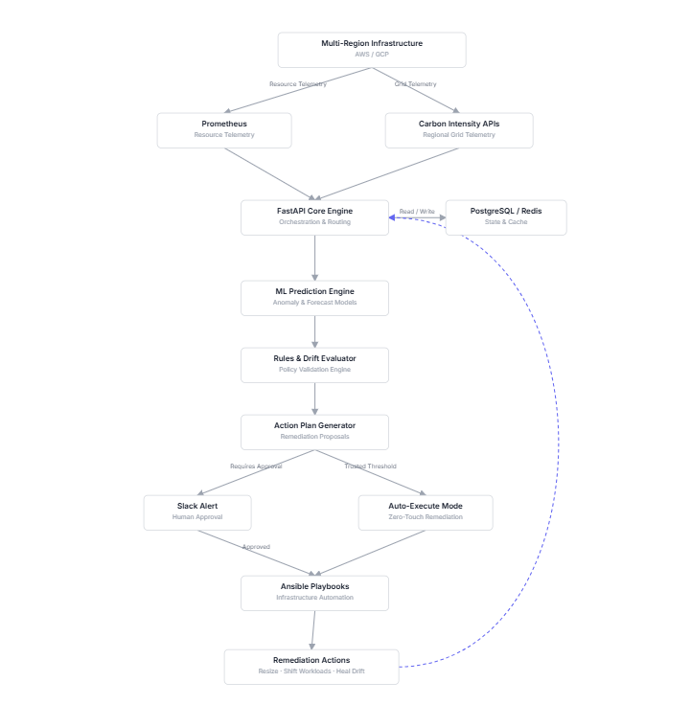

Technology Stack
Layer | Technology | Purpose
Infrastructure Management | Terraform | Multi-region, multi-cloud provisioning
Configuration Management | Ansible | Instance resizing, workload migration, self-healing
Backend API | FastAPI | Processing telemetry, rules, and automation jobs
Database | PostgreSQL | Persistent storage for metrics
Metrics | Prometheus | Real time collection of metrics
Environmental Telemetry | Cloud Carbon Footprint API | Live tracking of power grid carbon intensity across cloud regions
Frontend | React.js and CSS | Interactive UI

Execution Plan
Phase 1:
- Setup multi-region Terraform modules
- Deploy Prometheus and Metrics Exporters
- Build FastAPI Engine
- Develop traffic load and failure simulator
- Integrate Ansible playbooks
Phase 2:
- Integrate carbon intensity and cloud carbon footprint APIs
- Train and deploy predictive ML model
- Implement IaC drift detection and self-healing
- Conduct Live Migration tests and finalize UI

